Marking Changes in the Research Ethics’ Electronic Application Form
- To make amendments, the application is returned to the applicant, becomes visible on the applicant’s dashboard, and its status changes from “Submitted” to “In progress.”
- Download all fields of the electronic application under the “Submission” tab as a .pdf file.
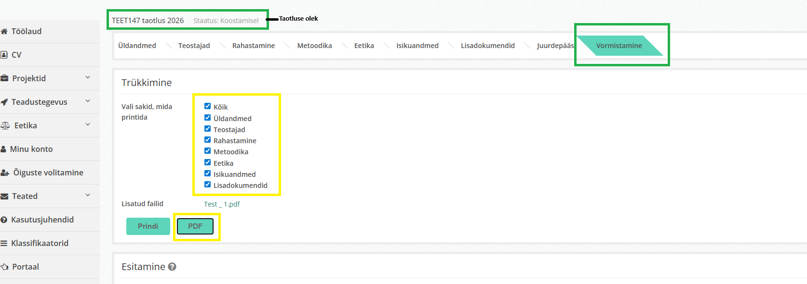
- Save the .pdf to your local device.
- Open the saved .pdf as a Word document.
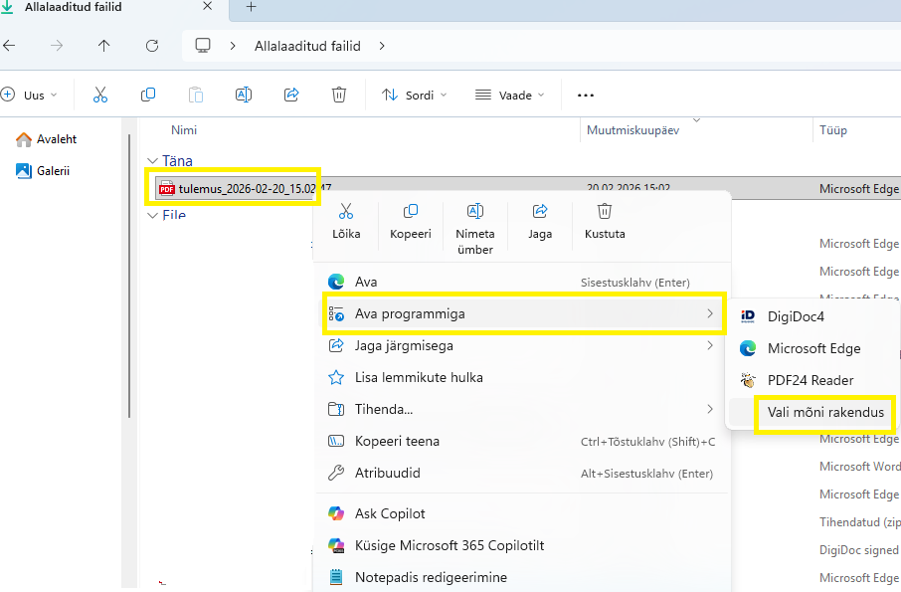
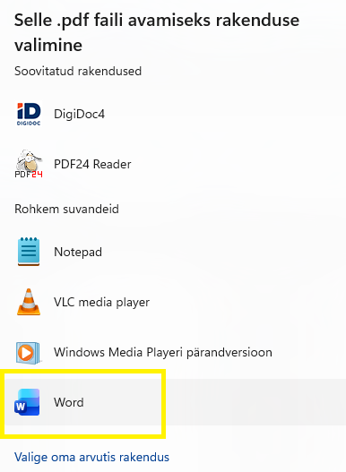
- Locate the sections of the electronic application form where you are making changes and mark the added or deleted text.
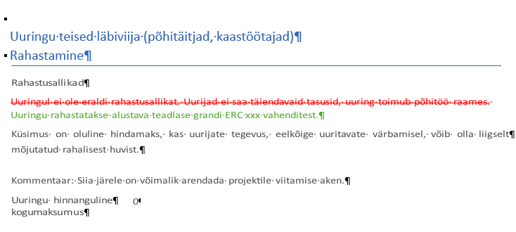
- Save the revised form and upload it to the application under the “Files” tab. Be sure to indicate in the description that this is the electronically marked-up version of the application form.

